**Module 3 Activity 1: MongoDB/Atlas setup**

Anudeep Anisetty

Information Technology, Arizona State University

IFT 554: Middleware Prog & Database Sec

Dinesh Sthapit

February 18, 2024

**Module 3 Activity 1: MongoDB/Atlas setup**

1. **Screenshot 1:** of the email confirmation from MongoDB Atlas

1. **Screenshot 2:** of the new project setup.

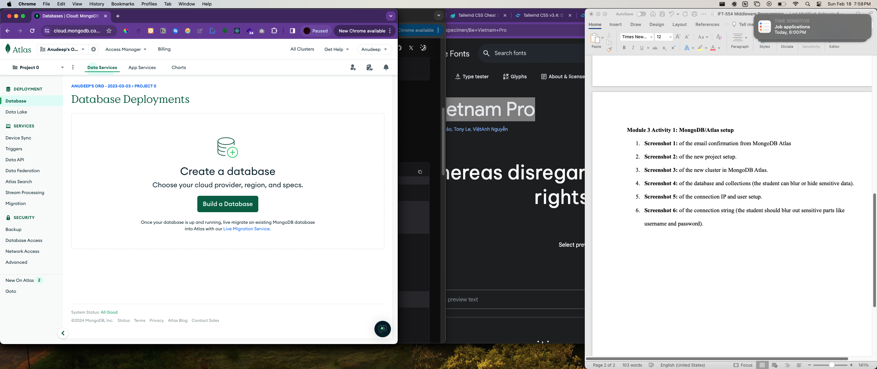

1. **Screenshot 3:** of the new cluster in MongoDB Atlas.

1. **Screenshot 4:** of the database and collections (the student can blur or hide sensitive data).

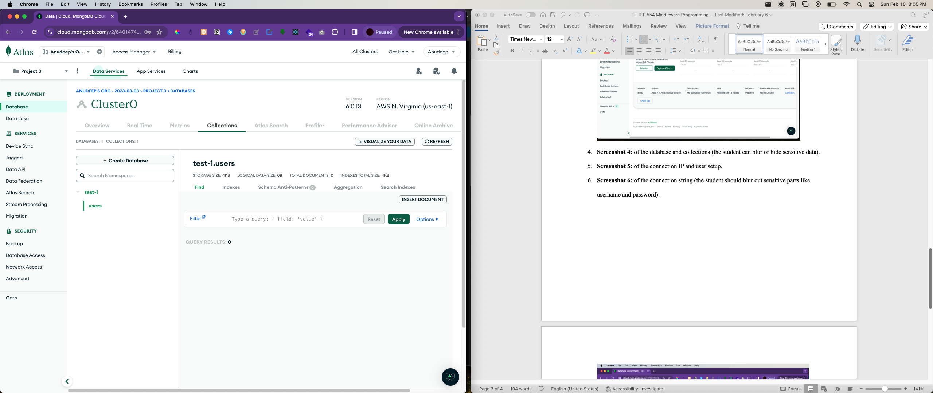

1. **Screenshot 5:** of the connection IP and user setup.

1. **Screenshot 6:** of the connection string (the student should blur out sensitive parts like username and password).

